LOAN APPROVAL PREDICTION

The domain of the Project: Banking & Financial Services

COURSE NAME: Data Analysis and Data Science

Team Mentors (and their designation):

Bhargavesh Dakka
Decision Scientist at MuSigma

Team Members:
Ms. Nagam Swathi

Period of the project

November 2025 to December 2025

Declaration

The project titled “Loan Approval Prediction” has been mentored by Bhargavesh Dakka, organised by SURE Trust, from May 2025 to December 2025, for the benefit of the educated unemployed rural youth for gaining hands-on experience in working on industry relevant projects that would take them closer to the prospective employer. I declare that to the best of my knowledge the members of the team mentioned below, have worked on it successfully and enhanced their practical knowledge in the domain.

Team Members:
Ms. Nagam Swathi

Mentor’s Name
Data Scientist—MuSigma

Prof. Radhakumari
Executive Director & Founder
SURE Trust

Table of contents
- Executive summary
- Introduction
- Project Objectives
- Methodology & Results
- Social / Industry relevance of the project
- Learning & Reflection
- Future Scope & Conclusion

Executive Summary

This project focuses on the development of an automated Loan Approval Prediction System designed to streamline the decision-making process for financial institutions. The primary objective was to leverage machine learning to accurately predict loan eligibility based on applicant profiles, thereby reducing the manual effort required for verification and minimizing the risk of financial defaults.
Methods and Technology: The system was built using a data-driven approach, involving extensive Exploratory Data Analysis (EDA) and preprocessing of historical loan data. Key machine learning algorithms, including Logistic Regression and Random Forest, were trained and evaluated to find the most reliable predictive model. Tools such as Python, Pandas, and Scikit-Learn were utilized to handle data cleaning, feature engineering, and model validation.

Introduction
Background and Context:
In the traditional banking landscape, the process of evaluating loan applications is heavily reliant on manual verification and human underwriting. With the exponential growth of financial data and an increasing number of applicants, banks require more sophisticated methods to manage credit risk. This project leverages historical data to build a predictive framework that assists financial institutions in identifying the creditworthiness of customers.

Problem Statement :
The primary challenge for banks is the risk of "bad loans," where borrowers fail to repay their debts, leading to significant financial losses. The goal of this project is to develop a machine learning model that can accurately predict whether a loan should be approved or rejected based on specific applicant criteria, thereby reducing human error and financial risk.
Scope and Limitations:
The scope of this project is limited to a classification task using a dataset of historical loan applications, focusing on features like income, credit history, and loan amount. A key limitation is that the model's accuracy is highly dependent on the quality and diversity of the historical data provided; it may not account for sudden shifts in global economic conditions or "black swan" events that affect repayment capacity.
Innovation Component:
The innovation in this project lies in the transition from a "rule-based" manual checklist to an "insight-based" automated system. By utilizing advanced algorithms like Random Forest or Gradient Boosting, the system can identify non-linear relationships between variables that a human officer might overlook.

Project Objectives
- To analyze loan applicant data using Exploratory Data Analysis (EDA) to identify key factors influencing loan approval.
- To understand customer risk patterns based on income, assets, loan amount, and credit score.
- To build a machine learning model to predict loan approval status.
- To compare baseline and advanced models such as Logistic Regression and Random Forest.
- To evaluate model performance using accuracy, precision, recall, F1-score, and confusion matrix.
- To reduce risky loan approvals by focusing on business-oriented evaluation metrics.

Methodology and Results
Following the structure required for the project documentation, here is the detailed methodology for the Loan Approval Prediction system:
- Methods and Technology Used:.
  - Implemented algorithms including Logistic Regression, Random Forest
  - Applied Feature Engineering to enhance model predictive power by creating new variables like "Total Assets".
- Tools and Software Used:
  - Python: Primary programming language for data processing and model building.
  - Pandas & NumPy: For data manipulation, cleaning, and numerical analysis.
  - Scikit-Learn: For implementing machine learning algorithms and evaluation metrics.
  - Matplotlib & Seaborn: For generating data visualizations and exploratory reports.
  - Jupyter Notebook: Integrated Development Environment (IDE) used for coding and documentation.
- Data Collection Approach:
  - Acquired a historical loan dataset from online.
  - Focused on key data points such as Cibil Score, Loan Term, Loan Amount, and Loan income ratio.
- Project Architecture:
  - Data Ingestion: Loading raw CSV data into a structured format for analysis.
  - Preprocessing: Handling missing values through mean/mode imputation and removing outliers.
  - Exploratory Data Analysis (EDA): Visualizing data distributions to understand correlations.
  - Model Training: Splitting data into training and testing sets to build the predictive engine.
  - Evaluation: Using a Confusion Matrix and Accuracy scores to validate the model's reliability.

Project GitHub Link:
https://github.com/suretrust/NAGAMSWATHIg7ds/tree/main/Final%20capstone%20project
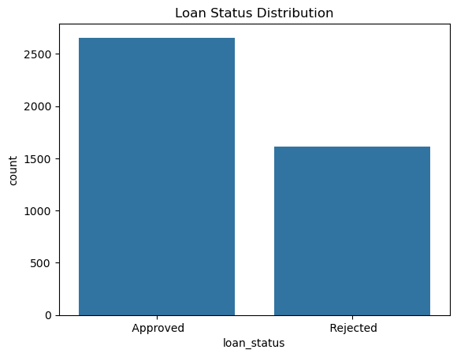
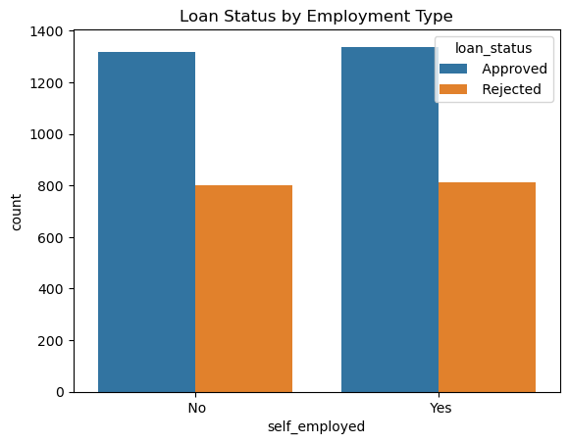
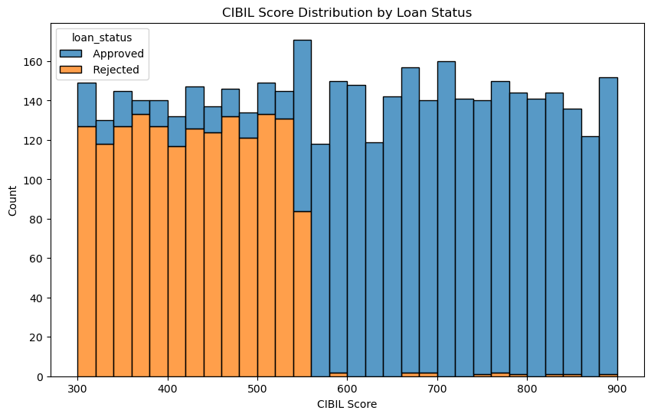

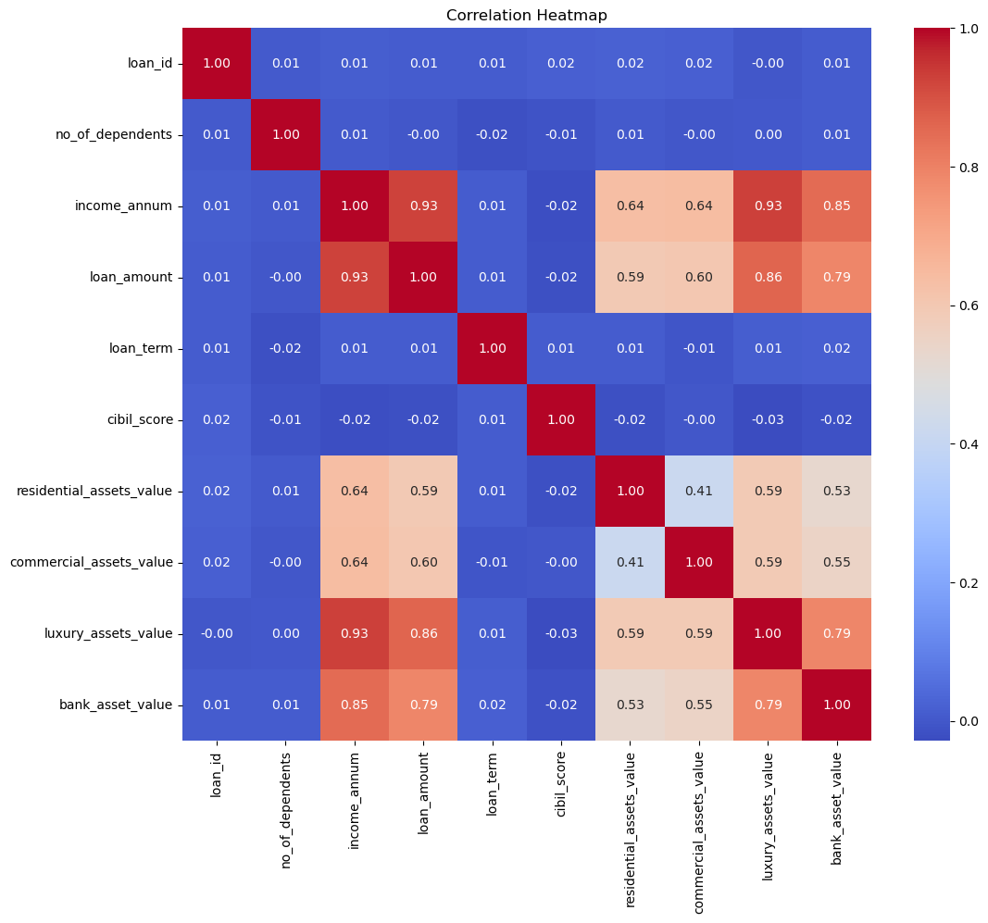
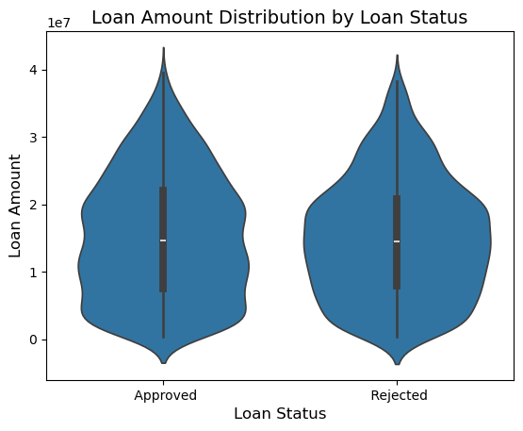

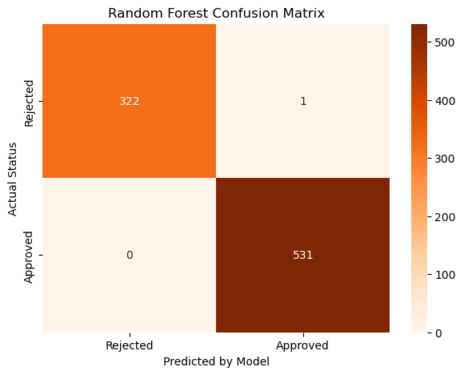
Learning and Reflection
Technical Learnings:
Gained hands-on experience in data cleaning, preprocessing and feature engineering.
Learned to implement predictive models using python and evaluate their performance.
Developed skills in data visualization.
Understand Integration of multiple tools (Excel,Python,Power bi) for end to end data analytics.
Management and Professional Learnings:
- Developed essential project management skills,Time Management, including setting milestones and meeting deadlines within the specified project period.
- Improved collaborative version control skills by managing the project code through a shared GitHub repository.
- Enhanced technical documentation abilities by structuring complex data findings into a format suitable for industry stakeholders.
Overall Experience:
- Gained hands-on experience in working with real-world banking and financial data.
- Understood the complete data science lifecycle from data cleaning to model evaluation.
- Learned how Exploratory Data Analysis (EDA) helps in identifying key risk factors affecting loan approval.
- Experienced the importance of handling data leakage and class imbalance in machine learning models.
- Improved skills in building and comparing machine learning models such as Logistic Regression and Random Forest.
- Developed the ability to interpret model results from a business and risk management perspective.
- Strengthened problem-solving, analytical thinking, and data storytelling skills.

Conclusion and Future Scope
Conclusion:
This project successfully developed a machine learning-based Loan Approval Prediction System that automates the evaluation of creditworthiness. By analyzing historical data, the system identifies high-risk applicants , significantly reducing the potential for human error and Non-Performing Assets (NPAs).
The findings confirm that Credit History is the most vital determinant of loan approval. This solution provides banks with a scalable, objective, and efficient tool to speed up the lending process while maintaining financial security.

FUTURE SCOPE
- Incorporate additional credit behavior data such as repayment history and transaction patterns.
- Apply advanced models like XGBoost or LightGBM for improved performance.
- Perform hyperparameter tuning and cross-validation to further optimize the model.
- Develop a real-time loan approval web application using the trained model.
- Integrate the system with bank databases for automated decision-making.
- Add explainable AI techniques to improve transparency in loan decisions.

